**What is docker hub and how it works- Create Docker hub account Dockerhub push and pull**

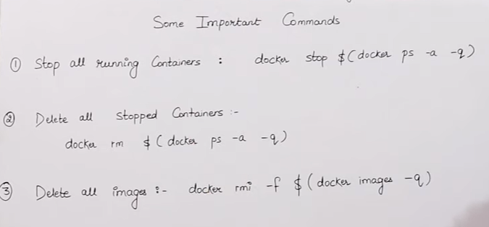

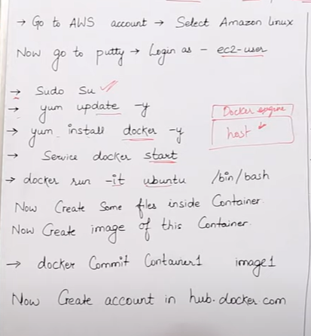

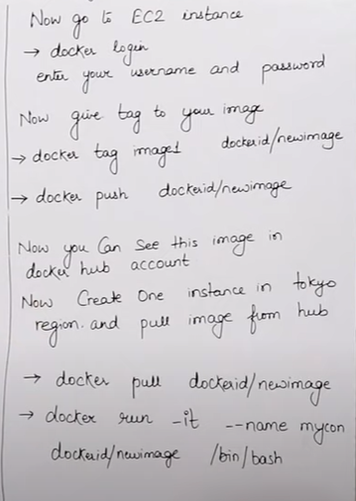

* **Mene eak container banaya**

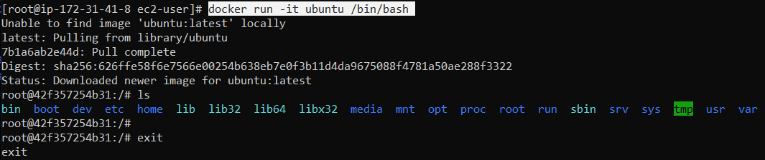



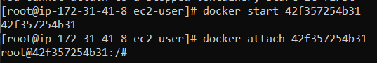

* **Mene apane container kein andar kuch files banayi hai**

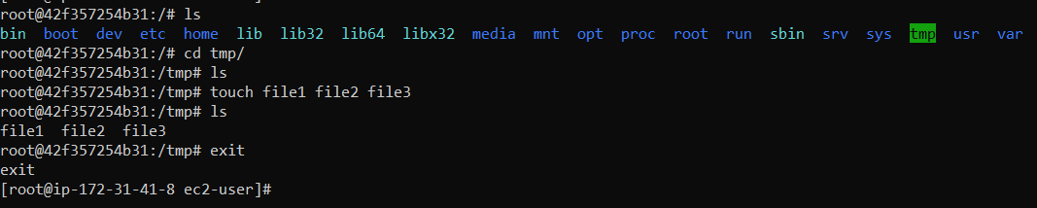

* **We have a docker image**

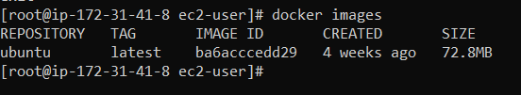

* **Our container:-**



* Mere pass **peaceful_bouman** naam ka jo container hai aur us container kein andar mene kuch files banayi hai us container ko mein image banana chahata hu toh container ko image mein convert karne kein liye mene commit use kiya hai



* Image is created

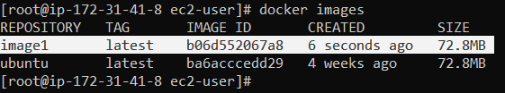

* Create account in dockerhub

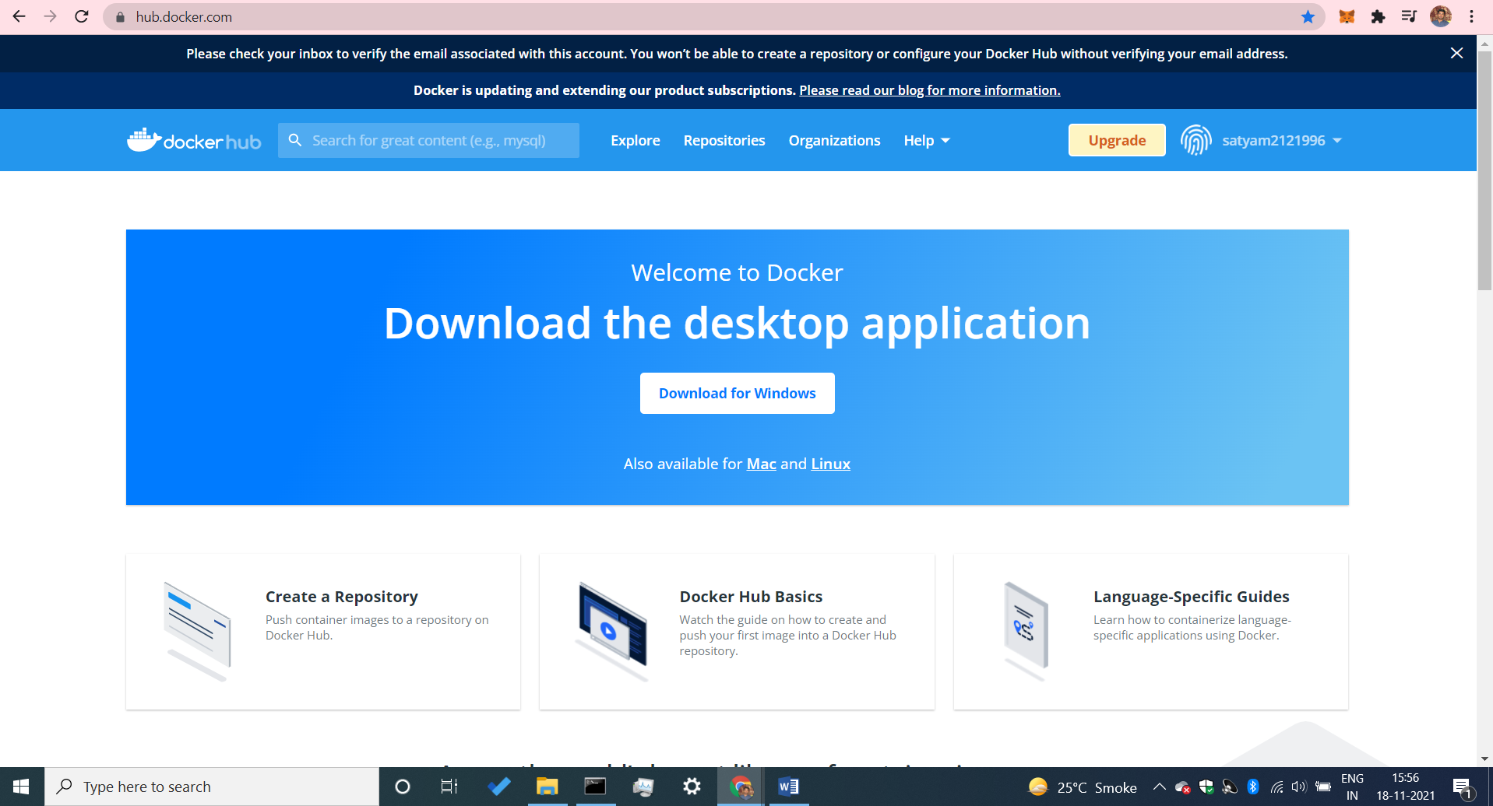

* Connect your docker hub account in your host machine

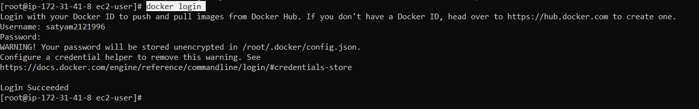

* Mein apane docker-hub par image dalna chahata hu vo image jo mene image1 kein naam sein create kiya hai us image ko mein docker hub par push arna chahata hu.
* Mene image1 ko tag diya hu matlab ki mere dockerhub account par meri ye image ka naam project1 hoga .
* Mene apane dockerhub ki id dalne kein baad tag name diya hai ki project1 kein naam sein iss image ko dockerhub par daal do



* Mene image k pehale tag name diya project1 kein naam sein aur phir us image ko mene push kar diya dockerhub account par apane.

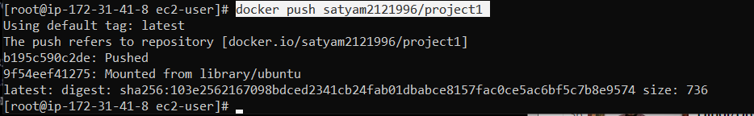

* Hum dekh sakte hai ki humari image humare dockerhub account par show hone lagi , aur ye public image hai hum dekh sakte hai us image mein likha hai ki public image hai yein.

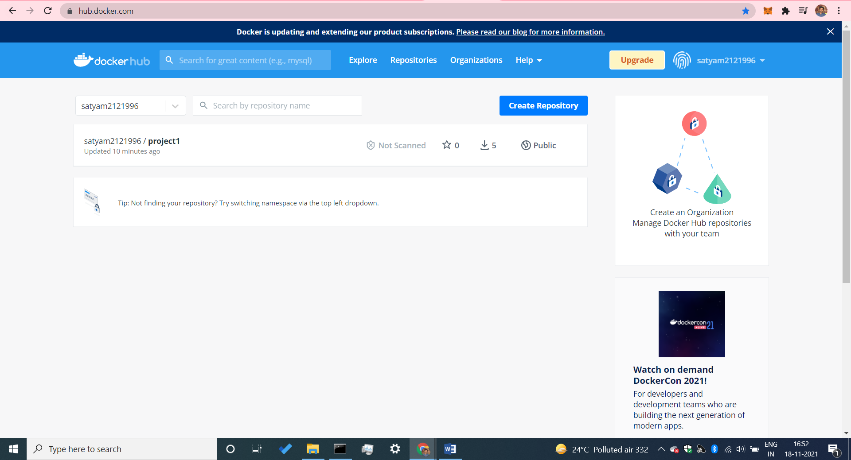

* Hum eak naya ec2 instance banayenge aur purana vala bhi chalne denge

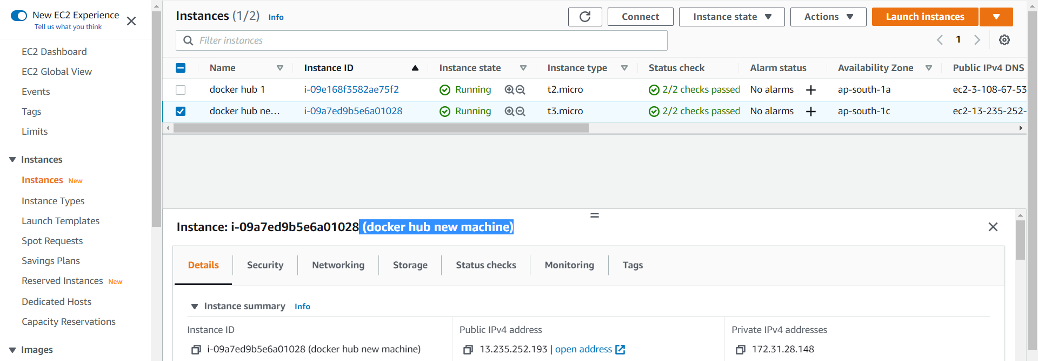

Run this command :-

[ec2-user@ip-172-31-28-148 ~]$ sudo su

[root@ip-172-31-28-148 ec2-user]# yum update –y

[root@ip-172-31-28-148 ec2-user]# yum install docker –y

* Abhi hum dekhenge ki humare new ec2 machine kein andar eak bhi image nahi hai.



* Ab hum apane purane vale instance sein jo project1 naam ki image push kiya thaa apane docker hub par ab us image ko hum apane new host machine kein andar dockerhub sein pull karlenge.

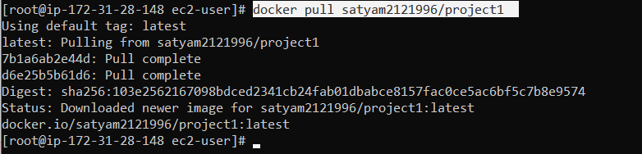

* Humari image dockerhub sein pull hoke humare account sein humare new host machine kein andar aagayi hai .

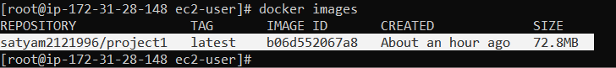

* Mene image ko container bana diya aur uske andar jaakar dekhunga ki jo file mene image mein pehale dala thaa vo file mene jab dockerhub sein pull kiya toh usme dikha raha hai ya nahi



* humane tmp folder kein andar ye file banayi thii aur jab docker image ko pull karke yaha laya new host machine kein andar toh sab file mujhe dikha rahi hai.

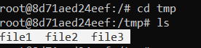

* agar mujhe apane image ko dockerhub par private karni hai toh hum uske liye is url par jayenge aur make private kar denge.

<https://hub.docker.com/repository/docker/satyam2121996/project1/settings>

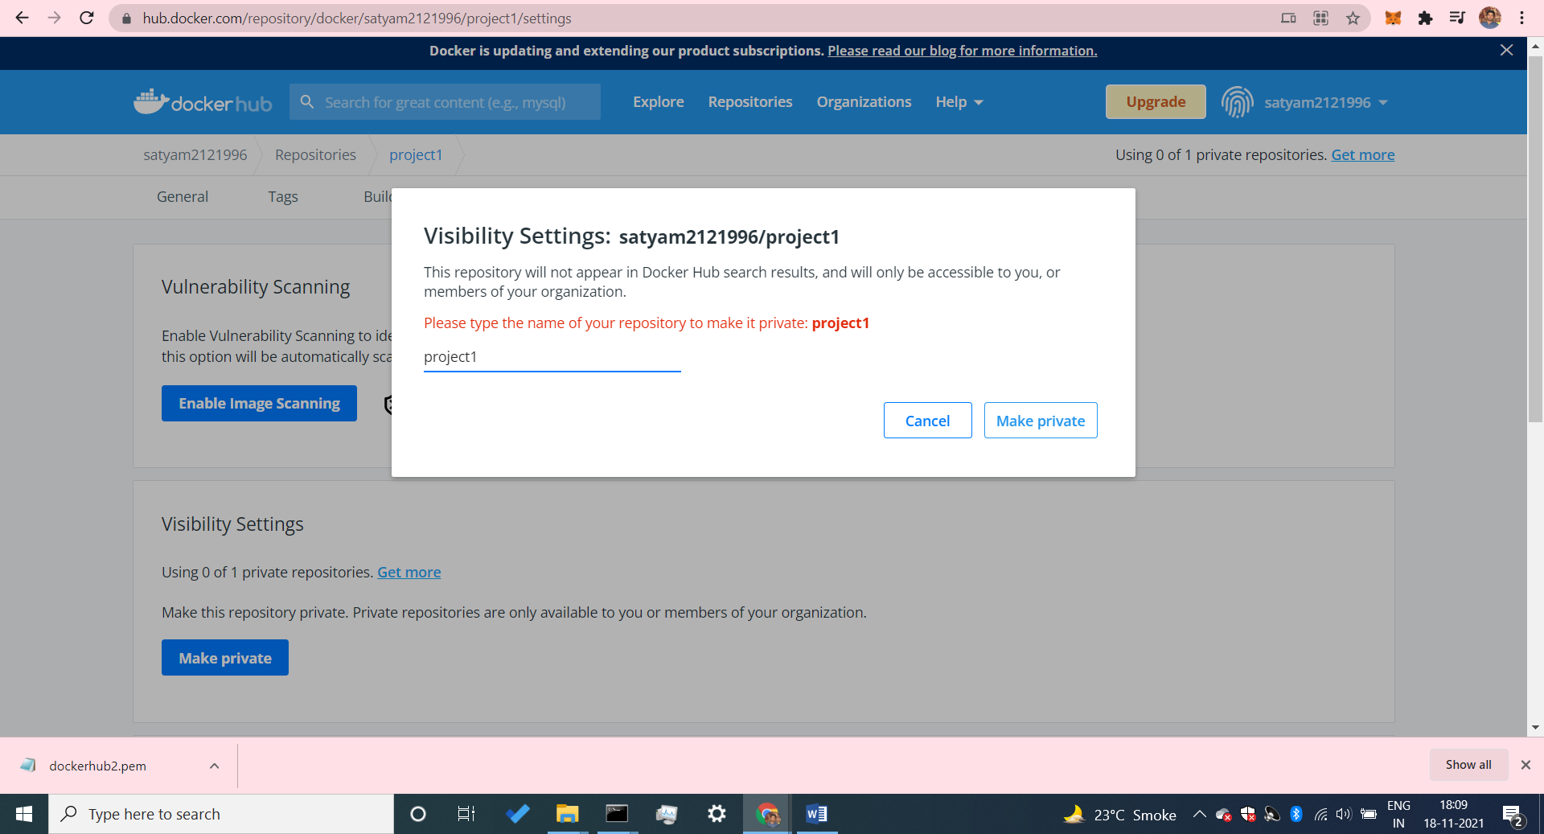

* ab hum dekhenge jaha make private likha aaraha thaa vaha make public likha aarha ab, humari image private ho gayi ab jiske pass username id password hoga kewal vahi humari image ko pull kar payega .

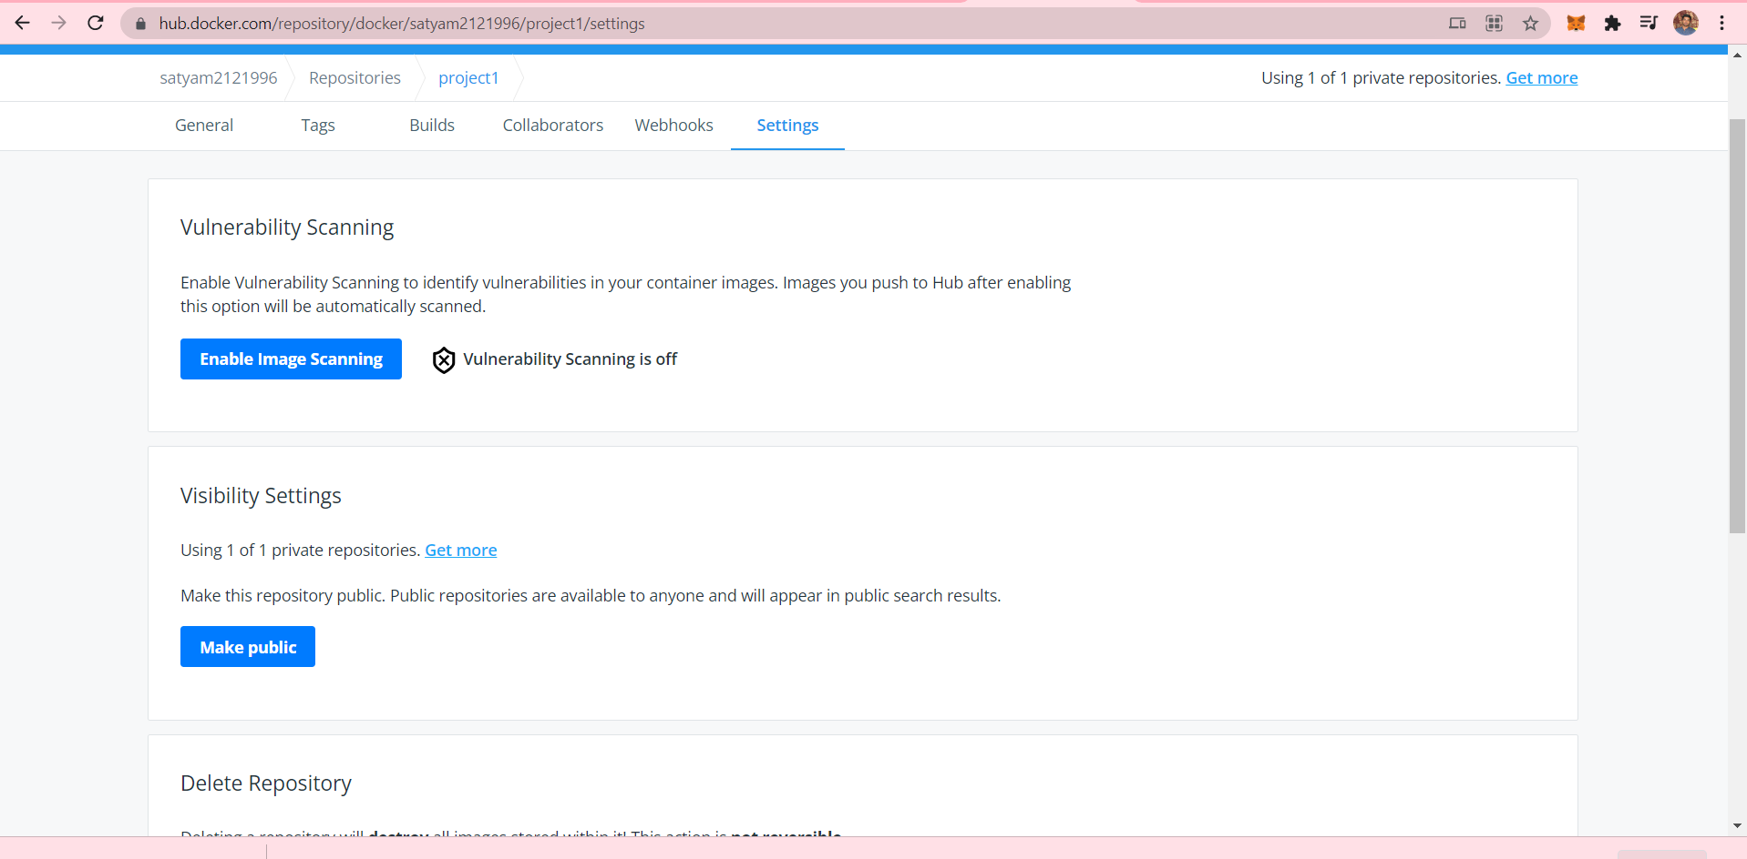

* humane jab image ko private kar diya uske baad bina login kare jab image ko pull kar rahe toh vo humko mana kar de raha keh raha pehale login karo



* mene apane new host machine kein andar docker login kar liya aur ab hum login karne kein baad again pull karenge

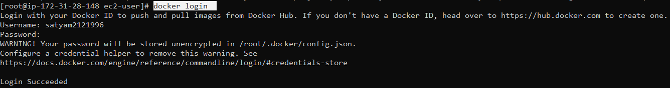

* humane login karne kein baad jab pull kiya toh humari image pull hokar aagayi

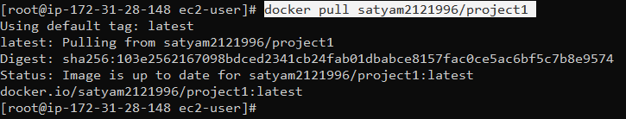

* agar docker hub sein bhi humko image delete karna hai toh settings mein jaake elete repository kar sakte hai .

